Saying ‘Jambo’ and sharing the Kenyan Vibe at the UPEI Global Village
By Anne Shileche, Queen Elizabeth II Diamond Jubilee Scholar
Jambo is the most famous greeting phrase used in Kenya. I want to believe that Kenya is somehow well known by people over the world, partly because of our excellent track record in long distance running. Nonetheless, I never miss the opportunity to talk about Kenya and its global positioning – it is one of the best known countries on the African continent.
The University of Prince Edward Island (UPEI) prides itself on having a multi-cultural student community. UPEI is always seeking ways to support its students, especially the international students, to live and integrate into the Canadian culture. Among the numerous activities assisting students to enjoy their studies and time on campus, one favorite event is the Global Village. The global village is a fun-filled afternoon and evening that gives international students an opportunity to showcase their culture. The Kenyan team thought of the Global Village event as an excellent place to share the vibe of their land with students from Prince Edward Island and the rest of the world.

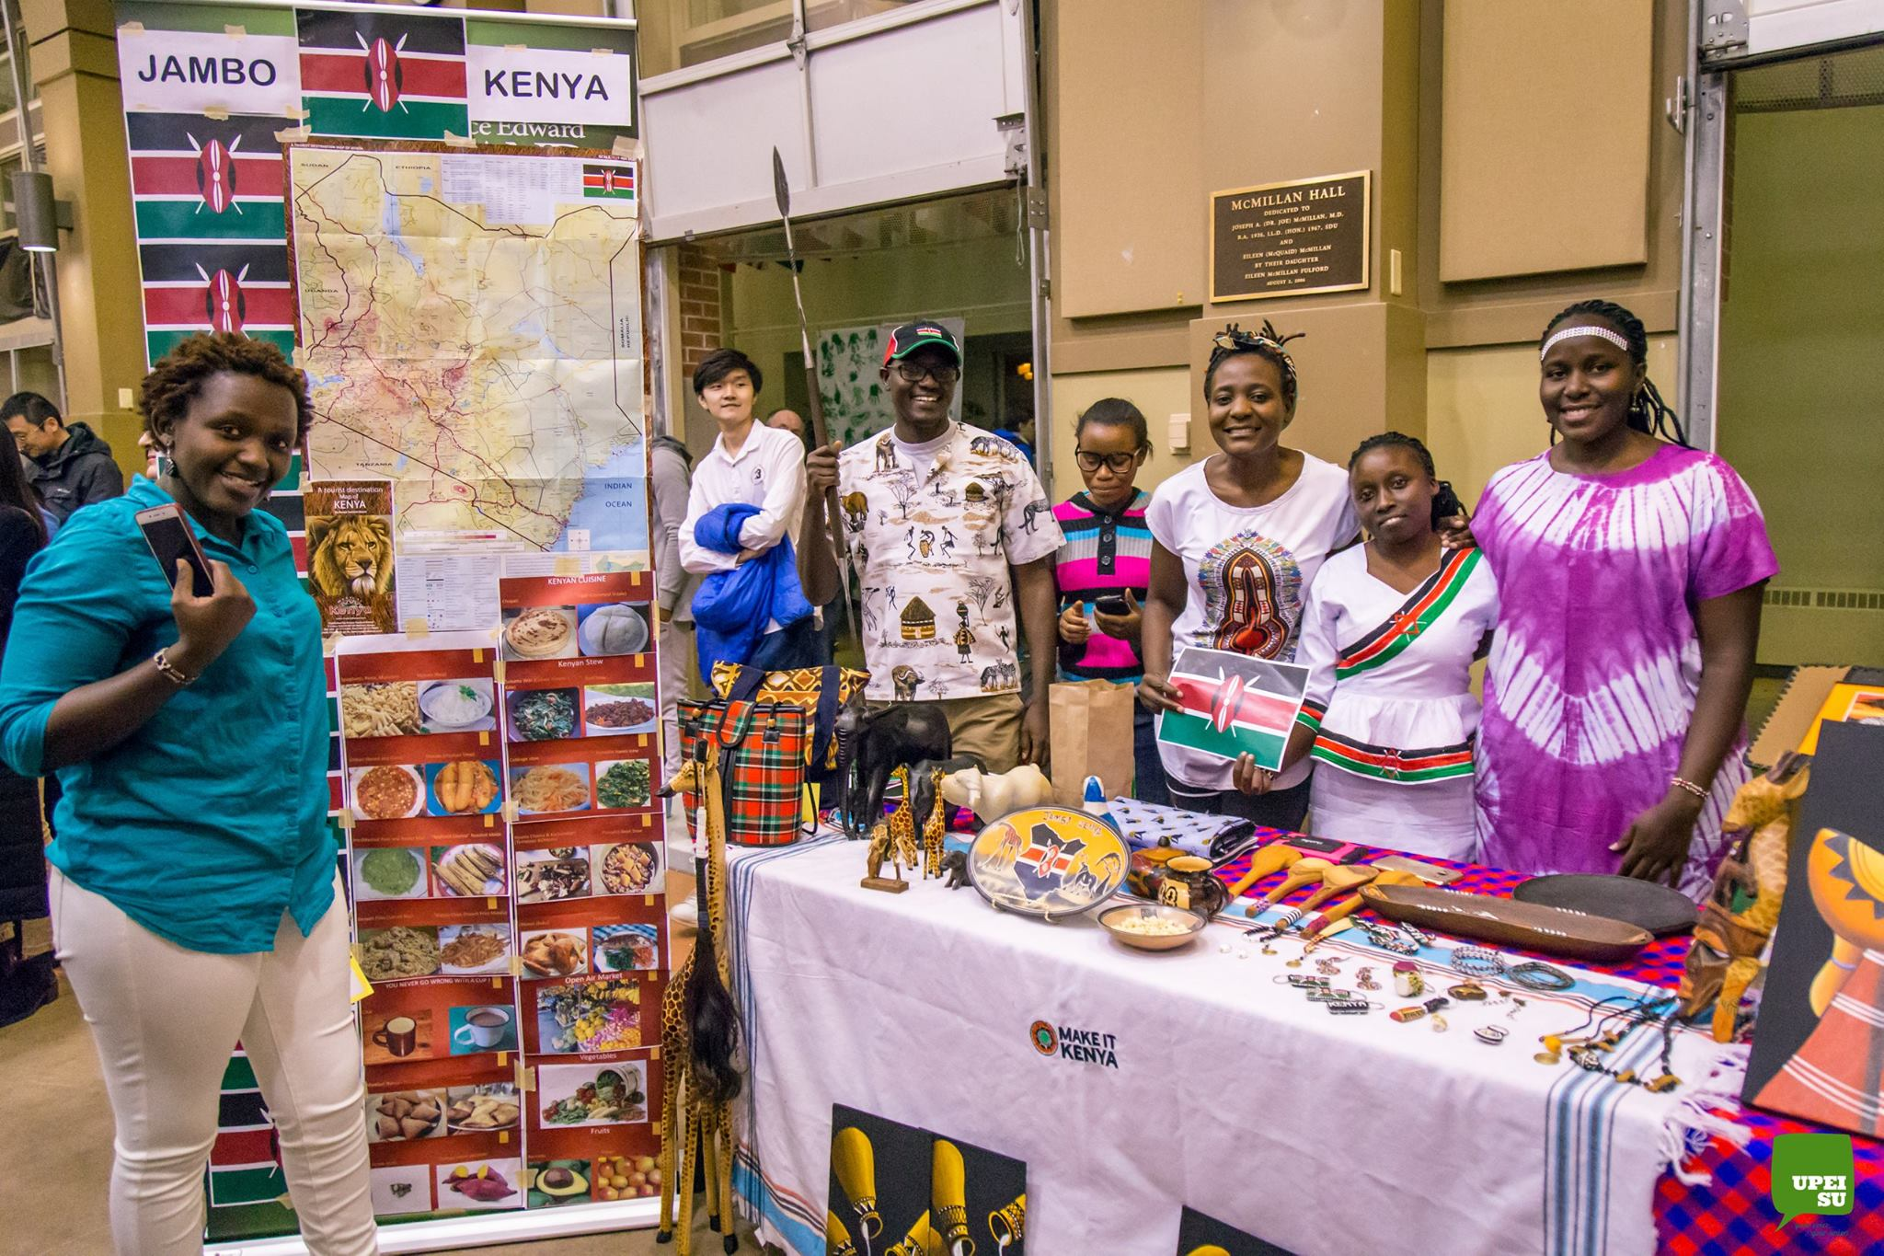
Kenyan team; from right, Peter, Dorcas, Anne, Grace and Sarah. Emily standing next to poster Credit: UPEI Student Union photographer Pravakar Thapa
It took the team a few weeks of planning for the event. As all Kenyans who participated in the event are graduate students, time was in short supply, and it took a lot of commitment to hold group meetings. We supplemented our physical sessions with the use of WhatsApp. Communication through the online group made things easier and faster, progress was tracked and problems solved by instant feedback. Tasks were distributed among members. The team settled on showcasing the Kenyan culture in the following themes: (1) National identity featuring the flag, emblems of the spear and Swahili language; (2) tourism featuring the big five animals; (3) indigenous tribes; (4) traditional foods; (5) art featuring bracelets and paintings; and (6) dressing style. We also reached out to several members of the UPEI Queen Elizabeth II Diamond Jubilee Scholarship Program led by John VanLeeuwen, and Farmers Helping Farmers, a nonprofit organization working in Kenya, who had been to Kenya and had some souvenirs.
Team members took turns to explain to visitors at the booth about Kenya in general and about the exhibits in specific. Guests were curious and asked questions about the wild animals; the taste of white corn, what we call maize; and why our flag had four colors. As we explained and answered questions, we could read excitement and amazement on the visitors’ faces, while others would express this loudly. I remember one person double checking that there were no winters in Kenya. Another wanted to know how he could volunteer for a wild animal conservancy. It was a proudly engaging moment for all members of the team. Having this opportunity to talk about things that identify the nation of Kenya and its people made us feel at home.

Anne demonstrating how to use the traditional spear
Before the end of the evening, I got a chance to visit several booths and learn about other world cultures. I went over to the Saudi Arabia station and observed their sparkling white robes with attractive head gears, tasted their sweet dates and strong Arabic coffee, and got a writing of my name in the Arabic language. At the Bahamas booth, I learned that this island nations is made up of a combination of over 700 small islands, each unique in its own way. One Bahamian talked about an island known for its pink sandy beaches. My attention was captured, and the Bahamas is added to my bucket list. Aside from the booths, there were electrifying presentations on the stage from countries including China, Spain, Iran, Rwanda, and Japan. The Global Village was a happy and fulfilling event for me. I look forward to taking part in it again during 2018 winter semester.

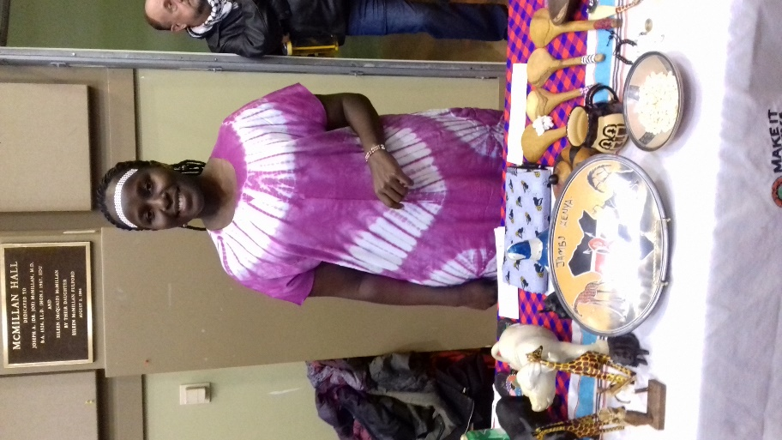
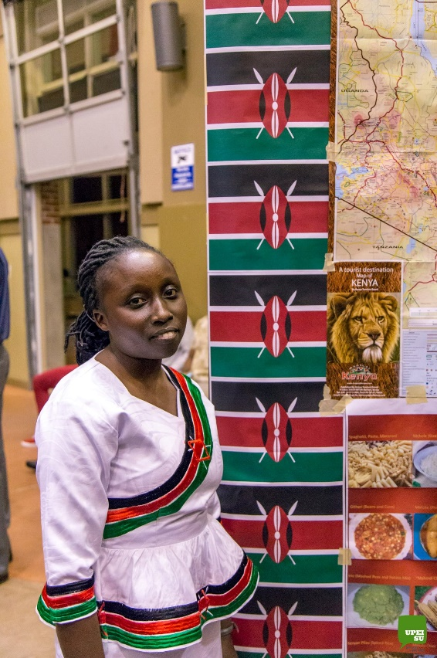
Grace showcasing her dress bearing the Kenyan flag Credit: UPEI Student Union photographer Pravakar Thapa
Sarah posing with some of Kenya’s essential artifacts

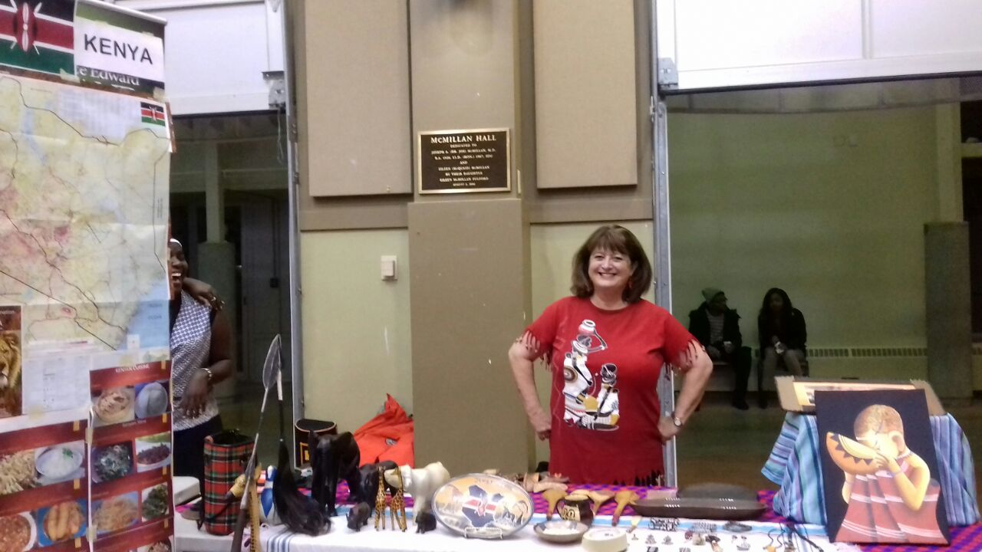
Jennifer Taylor (UPEI professor) came out to support Kenyans

